How to install webserver on Centos 6.3
[1] | Install httpd
[root@www ~]# yum -y install httpd
# remove welcome page
[root@www ~]# rm -f /etc/httpd/conf.d/welcome.conf

# remove default error page
[root@www ~]# rm -f /var/www/error/noindex.html

[2] | Configure httpd.
[root@www ~]# vi /etc/httpd/conf/httpd.conf
# line 44: change ServerTokens Prod
# line 76: change to ON
KeepAlive On
# line 262: Admin's address
ServerAdmin root@server.world
# line 276: change to your server's name
ServerName www.server.world:80
# line 338: change
AllowOverride All
# line 402: add file name that it can access only with directory's name
DirectoryIndex index.html index.htm
# line 536: change
ServerSignature Off
# line 759: make it comment

#AddDefaultCharset UTF-8
[root@www ~]# /etc/rc.d/init.d/httpd start
Starting httpd:
[ OK ]
[root@www ~]# chkconfig httpd on

[3] | Create a HTML test page and access to it with web browser. It's OK if following page is shown.  [root@www ~]# vi /var/www/html/index.html  <html>  <body>  <div style="width: 100%; font-size: 40px; font-weight: bold; text-align: center;">  Test Page  </div>  </body>  </html>

http://www.parktec.com/2013/02/web-server-on-centos-6-3/

Configure Proxy server and make web browzing fast. Install Squid for it.
[1] | Install and configure Squid
[root@prox ~]#
yum -y install squid
[root@prox ~]#
vi /etc/squid/squid.conf
acl CONNECT method CONNECT
# line 31: add ( define new ACL )
acl lan src 10.0.0.0/24
http_access allow localhost
# line 59: add ( allow defined ACL above )
http_access allow lan
# line 64: change
http_port 8080
# add at the last line
request_header_access Referer deny all
request_header_access X-Forwarded-For deny all
request_header_access Via deny all
request_header_access Cache-Control deny all
# add (specify hostname)

visible_hostname prox.server.world
# add (hide IP address)

forwarded_for off
[root@prox ~]# /etc/rc.d/init.d/squid start
Starting squid:
[ OK ]
[root@prox ~]#
chkconfig squid on

[2] | Start Web browser on your client PC. This is the example on Internet Explorer 9. Open [Internet Options] and move to [Connections] tab like below.

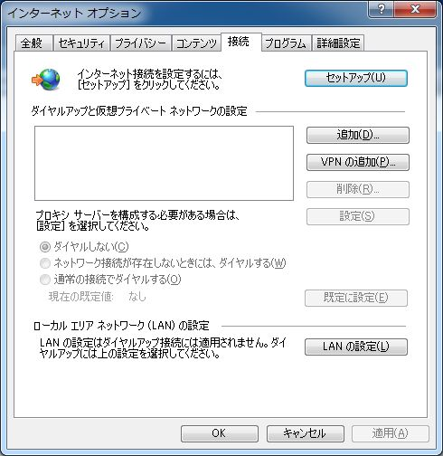

[3] | Check 'use a proxy' and input server's hostname and port number set in the section [1]. Then, you can access to internet through proxy server.
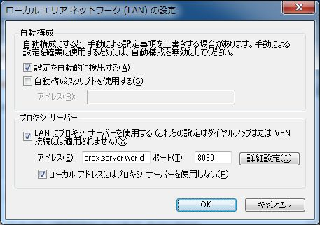

 | Install SquidClamav and Configure Proxy Server in order to scan download files to protect from virus. Install Clamav first.
[1] | Install Clamd
[root@prox ~]# yum --enablerepo=rpmforge -y install clamd # install from RPMforge
[root@prox ~]# /etc/rc.d/init.d/clamd start
Starting Clam AntiVirus Daemon: Bytecode: Security mode set to "TrustSigned".
[ OK ]
[root@prox ~]# chkconfig clamd on
[2] | Install c-icap
[root@prox ~]# wget http://ftp.jaist.ac.jp/pub/sourceforge/c/project/c-/c-icap/c-icap/0.1.x/c_icap-0.1.6.tar.gz
[root@prox ~]# tar zxvf c_icap-0.1.6.tar.gz
[root@prox ~]# cd c_icap-0.1.6
[root@prox c_icap-0.1.6]# ./configure
[root@prox c_icap-0.1.6]# make
[root@prox c_icap-0.1.6]# make install
[root@prox c_icap-0.1.6]# cd
[root@prox ~]# cp /usr/local/etc/c-icap.conf /etc

[root@prox ~]# vi /etc/c-icap.conf
# line 140: change admin address
ServerAdmin root@server.world
# line 149: change to your server name
ServerName prox.server.world
# line 497: add
Service squidclamav squidclamav.so
[root@prox ~]# vi /etc/rc.d/init.d/c-icap
# create init script
#!/bin/bash

# c-icap: Start/Stop c-icap
# chkconfig: - 70 30
# description: c-icap is an implementation of an ICAP server.
# processname: c-icap
# pidfile: /var/run/c-icap/c-icap.pid

. /etc/rc.d/init.d/functions
. /etc/sysconfig/network

CONFIG_FILE=/etc/c-icap.conf
PID_DIR=/var/run/c-icap

RETVAL=0
start() {
echo -n $"Starting c-icap: "
daemon /usr/local/bin/c-icap -f $CONFIG_FILE
RETVAL=$?
echo
[ $RETVAL -eq 0 ] && touch /var/lock/subsys/c-icap
return $RETVAL
}
stop() {
echo -n $"Stopping c-icap: "
killproc c-icap
rm -f /var/run/c-icap/c-icap.ctl
RETVAL=$?
echo
[ $RETVAL -eq 0 ] && rm -f $PID_DIR/c-icap.pid /var/lock/subsys/c-icap
return $RETVAL
}
case "$1" in
start)
start
;;
stop)
stop
;;
status)
status c-icap
;;
restart)
stop
start
;;
*)
echo $"Usage: $0 {start|stop|status|restart}"
exit 1
esac
exit $?

[root@prox ~]# chmod 755 /etc/rc.d/init.d/c-icap

[3] | Install SquidClamav ( Download latest version of it from the following link )
http://sourceforge.net/projects/squidclamav/files/squidclamav/

[root@prox ~]# wgethttp://ftp.jaist.ac.jp/pub/sourceforge/s/project/sq/squidclamav/squidclamav/6.3/squidclamav-6.3.tar.gz
[root@prox ~]# tar zxvf squidclamav-6.3.tar.gz
[root@prox ~]# cd squidclamav-6.3
[root@prox squidclamav-6.3]# ./configure
[root@prox squidclamav-6.3]# make
[root@prox squidclamav-6.3]# make install
[root@prox squidclamav-6.3]# cd

[root@prox ~]# vi /etc/squidclamav.conf
# line 17: change( destination URL for redirect. Create it first )
redirect
http://www.server.world/error.html
# line 25: change( same with clamd )
clamd_local /var/run/clamav/clamd.sock
[root@prox ~]# /etc/rc.d/init.d/c-icap start
Starting c-icap:
[ OK ]
[root@prox ~]# chkconfig --add c-icap
[root@prox ~]# chkconfig c-icap on

[4] | Configure Squid
[root@prox ~]# vi /etc/squid/squid.conf
# add at the last line

icap_enable on
icap_send_client_ip on
icap_send_client_username on
icap_client_username_header X-Authenticated-User
icap_service service_req reqmod_precache bypass=1 icap://127.0.0.1:1344/squidclamav
adaptation_access service_req allow all
icap_service service_resp respmod_precache bypass=1 icap://127.0.0.1:1344/squidclamav
adaptation_access service_resp allow all
[root@prox ~]# /etc/rc.d/init.d/squid restart
Stopping squid: ................[ OK ]
Starting squid: .[ OK ]

[5] | Try to access to a page that has trial virus from here.  http://eicar.org/85-0-Download.html  Click 'eicar.com' and rty to download it. Then, the error page that is set in the config of squidclamav. Virus is blocked normally.
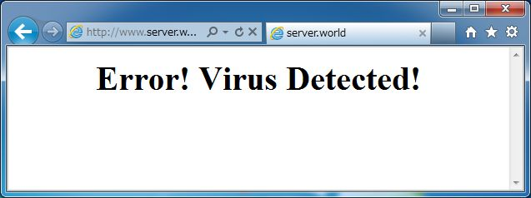
 |  | Run Squid with SquidGuard that is a URL redirector. Configure squidClamav first.
[1] |  |  | Install and configure SquidGuard (this config is most simply example)

[root@prox ~]# yum --enablerepo=rpmforge -y install squidguard # install from RPMforge
[root@prox ~]# mv /etc/squid/squidguard.conf /etc/squid/squidguard.conf.bk

[root@prox ~]# vi /etc/squid/squidguard.conf
# create new

dbhome /var/lib/squidguard/db
logdir /var/log/squidguard
# define a category 'deny'
dest deny {
# prohibited domain list

domainlist deny/domains

# prohibited url list

urllist deny/urls

}
acl {
default {

# allow to access except 'deny'

pass !deny all

# redirect URL

redirect http://www.server.world/error.html

}
}
[root@prox ~]# mkdir /var/log/squidguard
[root@prox ~]# mkdir -p /var/lib/squidguard/db/deny

[root@prox ~]# vi /var/lib/squidguard/db/deny/domains
# write domains you'd like to prohibit to access

yahoo.co.jp
example.com
[root@prox ~]# vi /var/lib/squidguard/db/deny/urls
# write URLs you'd like to prohibit to access

www.yahoo.co.jp/deny/
www.example.com/
[root@prox ~]#
squidGuard -C all

Processing file and database /var/lib/squidguard/db/deny/domains
[==================================================] 100 % done
Processing file and database /var/lib/squidguard/db/deny/urls
[==================================================] 100 % done
[root@prox ~]# chown -R squid. /var/lib/squidguard/db/deny

[root@prox ~]# vi /etc/squidclamav.conf
# line 20: uncomment and change PATH
squidguard
/usr/bin/squidguard
[root@prox ~]# /etc/rc.d/init.d/c-icap restart
Stopping c-icap:
[ OK ]
Starting c-icap:
[ OK ]

[2] | Try to access to Yahoo set as prohibited domain in [1]. Prohibited domain is blicked normally.
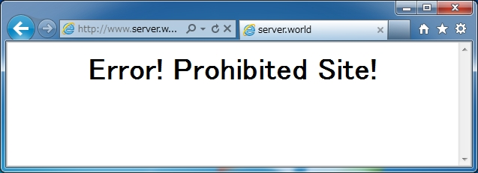

 | Install DansGuardian to block some contents.
[1] | Install DansGuardian
[root@prox ~]# yum --enablerepo=rpmforge -y install dansguardian # install from RPMforge
[root@prox ~]# vi /etc/dansguardian/dansguardian.conf
# line 88: specify the port DansGuardian listens
filterport = 8081
# line 94 : specify the port Proxy server listens
proxyport = 8080
[root@prox ~]# /etc/rc.d/init.d/dansguardian start
Starting Web Content Filter (dansguardian): [ OK ]
[root@prox ~]# chkconfig dansguardian on

[2] | Configuration of Filtering
[root@prox ~]# vi /etc/dansguardian/lists/bannedsitelist
# specify domain names you'd like to block

yahoo.co.jp
[root@prox ~]# /etc/rc.d/init.d/dansguardian restart
Shutting down Web Content Filter (dansguardian): [ OK ]
Starting Web Content Filter (dansguardian): [ OK ]
# other lists you can define
# other lists you can define
bannedextensionlist  bannediplist  bannedmimetypelist  bannedphraselist  bannedregexpheaderlist  bannedregexpurllist  bannedsitelist  bannedurllist  contentregexplist  exceptionextensionlist  exceptionfilesitelist  ⇒ exception file domain  exceptionfileurllist  ⇒ exception file URL  exceptioniplist  ⇒ exception client IP address  exceptionmimetypelist  ⇒ exception MIME Type  exceptionphraselist  ⇒ exception phrase  exceptionregexpurllist  ⇒ exception URL(regexp)  exceptionsitelist  ⇒ exception domain  exceptionurllist  ⇒ exception URL  filtergroupslist  ⇒ filter group  greysitelist  ⇒ grey domain  greyurllist  ⇒ grey URL | ⇒ banned edextension  ⇒ banned client IP address  ⇒ banned MIME Type  ⇒ banned phrase  ⇒ banned header(regexp)  ⇒ banned URL(regexp)  ⇒ banned domain  ⇒ banned URL  ⇒ replace contents(regexp)  ⇒ exception extension

[3] | Try to access the banned domain you set, then the access has been redirected like follows.

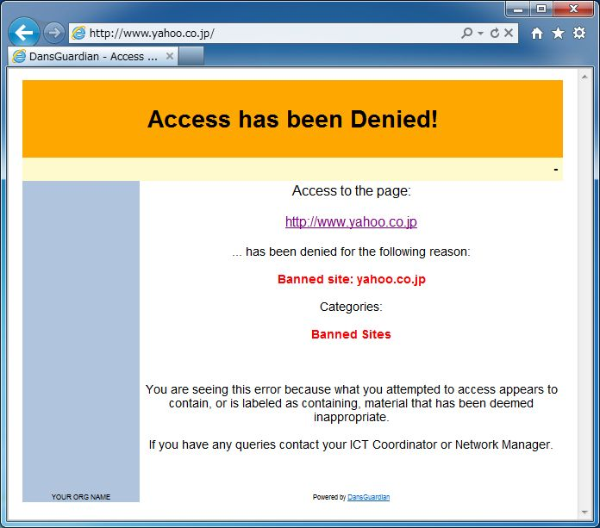

Install LightSquid to generate Squid Log Report.
[1] | Install LightSquid

[root@prox ~]# yum --enablerepo=epel -y install lightsquid lightsquid-apache # install from EPEL
[root@prox ~]# vi /etc/httpd/conf.d/lightsquid.conf
<Directory /usr/share/lightsquid/cgi>
DirectoryIndex index.cgi
Options ExecCGI
AddHandler cgi-script .cgi
AllowOverride None

# IP address you permit
Order Deny,Allow
Deny from all
Allow from 127.0.0.1 10.0.0.0/24
</Directory>
[root@prox ~]# /etc/rc.d/init.d/httpd restart
Stopping httpd: [ OK ]
Starting httpd: [ OK ]
# generate log report
[root@prox ~]# /usr/sbin/lightparser.pl
# log report is generated every day by cron

[2] | Access to "http://(server's hostname or IP address)/lightsquid/" with web browser, then, following Squid log report is shown.
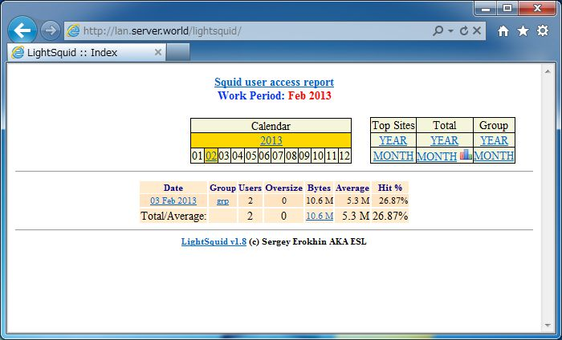

 | Configure Squid as a reverse proxy server.
[1] | Configure Squid
[root@prox ~]# vi /etc/squid/squid.conf
# near line 60: add (allow all http access)

http_access allow all
# line 64: specify Web server's IP address which listens requests
http_port
80 defaultsite=10.0.0.31
# add at the last line

cache_peer 10.0.0.31 parent 80 0 no-query originserver
[root@prox ~]# /etc/rc.d/init.d/squid restart
Stopping squid: ................[ OK ]
Starting squid: .[ OK ]
[2] | Change Settings of DNS or router if needed, and access to verify settings.
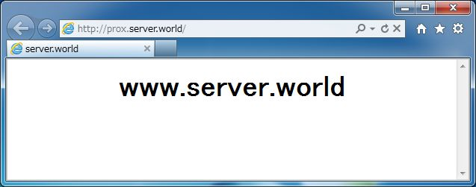
http://www.server-world.info/en/note?os=CentOS_6&p=squid&f=4

 | Install Samba and Create a shared directory that anybody can read and write, and authentication is not needed.
[1] | Install and Configure Samba
[root@lan ~]# yum -y install samba
[root@lan ~]# mkdir /home/share
[root@lan ~]# chmod 777 /home/share

[root@lan ~]# vi /etc/samba/smb.conf
# near line 58: add

unix charset = UTF-8
dos charset = CP932
# line 75: change (Windows' default)
workgroup = WORKGROUP
# line 81: uncomment and change IP address you allow
hosts allow = 127. 10.0.0.
# line 102: change (no auth)
security = share
# add at the bottom

[Share] # any name you like
path = /home/share # shared directory
writable = yes # writable
guest ok = yes # guest OK
guest only = yes # guest only
create mode = 0777 # fully accessed
directory mode = 0777 # fully accessed
share modes = yes # warn if some people access to a file
[root@lan ~]# /etc/rc.d/init.d/smb start
Starting SMB services:
[ OK ]
[root@lan ~]# /etc/rc.d/init.d/nmb start
Starting NMB services:
[ OK ]
[root@lan ~]# chkconfig smb on
[root@lan ~]# chkconfig nmb on
[2] | Configure on Windows client. This example is on Windows 7. Select [My Computer] - [Map Network Drive] like following example.
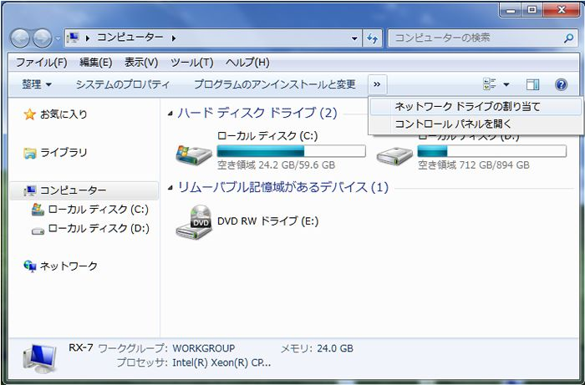

[3] | Specify shared folder's place in Folder section like example and Click 'Finish' button to enter.
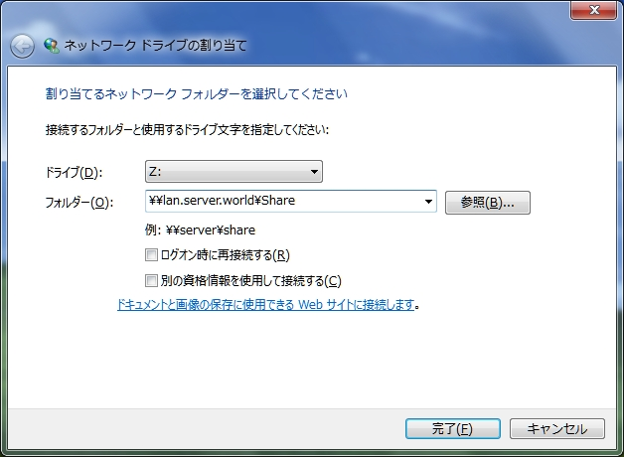

[4] | Done to access to shared folder.
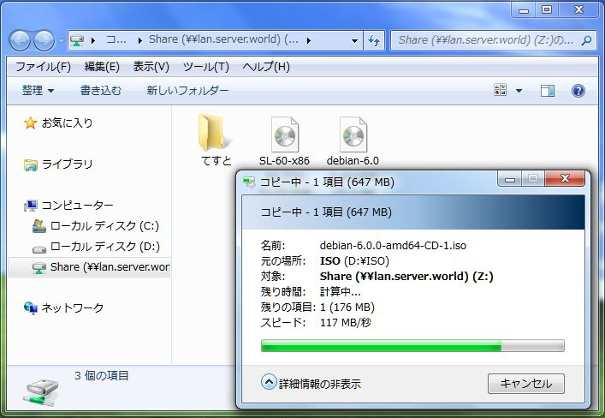

 | Create a shared directory that requires user authentication.
[1] | Configure Samba
[root@lan ~]# groupadd security
[root@lan ~]# mkdir /home/security
[root@lan ~]# chgrp security /home/security
[root@lan ~]# chmod 770 /home/security

[root@lan ~]# vi /etc/samba/smb.conf
# line 102: change
security = user
# add at the last line

[Security] # any name you like
path = /home/security
writable = yes
create mode = 0770
directory mode = 0770
share modes = yes
guest ok = no # guest not allowed
valid users = @security # allow only security group
[root@lan ~]# /etc/rc.d/init.d/smb restart
Shutting down SMB services:
[ OK ]
Starting SMB services:
[ OK ]
[root@lan ~]# smbpasswd -a cent # add a user in Samba
New SMB password: # set password
Retype new SMB password: # confirm
Added user cent.
[root@lan ~]# vi /etc/group
security:x:502:cent # add

[2] | Configure on Windows client. This example is on Windows 7.  Select [My Computer] - [Map Network Drive] like following example.

[3] | Input '\\(server)\(shared directory)'
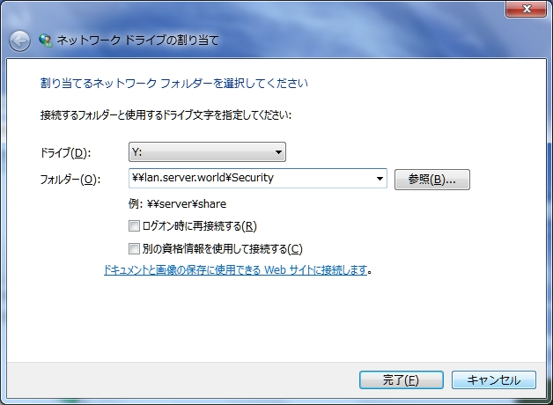
[4] | Password is required. Input the one set in [1].
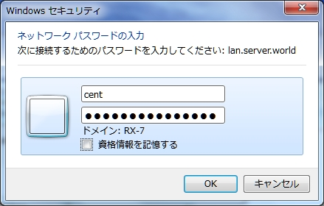

[5] | Just accessed.

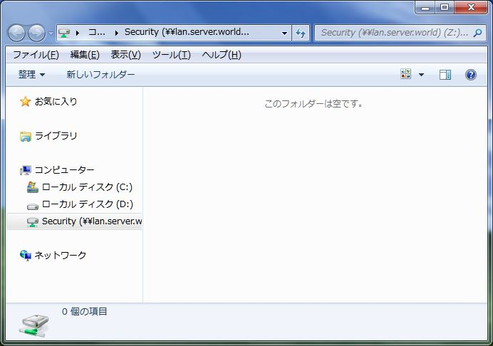

 | Install SWAT to configure Samba from Web browser.
[1] | Install xinetd and SWAT
[root@lan ~]# yum -y install xinetd samba-swat
[root@lan ~]# vi /etc/xinetd.d/swat
# line 10: add IP address you permit
only_from = 127.0.0.1 10.0.0.0/24
# line 14: change
disable = no
[root@lan ~]# /etc/rc.d/init.d/xinetd start
Starting xinetd:
[ OK ]
[root@lan ~]# chkconfig xinetd on

[2] | Access to [http://(server's hostname or IP address):901]. After accessing, user name and password is required to login. Input for root's one in it and login, then following screen is shown and you can configure samba on browser.
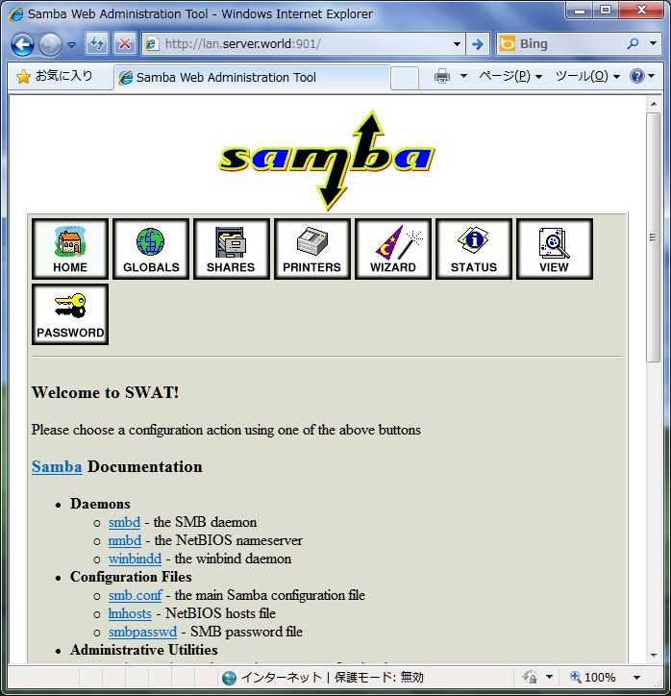

Configure Primary Domain Controller with Samba + OpenLDAP. LDAP Server is running on your LAN and also the server you'd like to configure PDC need to be a LDAP Client.

[1] | Chane OpenLDAP settings

[root@dir ~]#
wget http://ftp.riken.jp/Linux/centos/6.0/os/x86_64/Packages/samba-3.5.4-68.el6.x86_64.rpm
[root@dir ~]#
mkdir tmp
[root@dir ~]#
cd tmp
[root@dir tmp]#
rpm2cpio ~/samba-3.5.4-68.el6.x86_64.rpm | cpio -id
[root@dir tmp]#
cp ./etc/openldap/schema/samba.schema /etc/openldap/schema/

[root@dir tmp]#
vi schema_convert.conf
# create new

include /etc/openldap/schema/core.schema
include /etc/openldap/schema/collective.schema
include /etc/openldap/schema/corba.schema
include /etc/openldap/schema/cosine.schema
include /etc/openldap/schema/duaconf.schema
include /etc/openldap/schema/dyngroup.schema
include /etc/openldap/schema/inetorgperson.schema
include /etc/openldap/schema/java.schema
include /etc/openldap/schema/misc.schema
include /etc/openldap/schema/nis.schema
include /etc/openldap/schema/openldap.schema
include /etc/openldap/schema/ppolicy.schema
include /etc/openldap/schema/samba.schema
[root@dir tmp]#
mkdir ldif_output
[root@dir tmp]#
slapcat -f schema_convert.conf -F ./ldif_output -n0 -s "cn={12}samba,cn=schema,cn=config" > ./cn=samba.ldif

[root@dir tmp]#
vi cn=samba.ldif
# line 1,3: change ( remove "{12}" )
dn: cn=samba,cn=schema,cn=config
objectClass: olcSchemaConfig
cn: samba
# remove these lines below ( placed at the bottom )
structuralObjectClass: olcSchemaConfig
entryUUID: 761ed782-e76d-102f-94de-7784c8a781ec
creatorsName: cn=config
createTimestamp: 20110320184149Z
entryCSN: 20110320184149.954974Z#000000#000#000000
modifiersName: cn=config
modifyTimestamp: 20110320184149Z
[root@dir tmp]#
ldapadd -Y EXTERNAL -H ldapi:/// -f cn=samba.ldif
SASL/EXTERNAL authentication started
SASL username: gidNumber=0+uidNumber=0,cn=peercred,cn=external,cn=auth
SASL SSF: 0
adding new entry "cn=samba,cn=schema,cn=config"
[root@dir tmp]#
vi samba_indexes.ldif
# create new

dn: olcDatabase={2}hdb,cn=config
changetype: modify
add: olcDbIndex
olcDbIndex: uidNumber eq
olcDbIndex: gidNumber eq
olcDbIndex: loginShell eq
olcDbIndex: uid eq,pres,sub
olcDbIndex: memberUid eq,pres,sub
olcDbIndex: uniqueMember eq,pres
olcDbIndex: sambaSID eq
olcDbIndex: sambaPrimaryGroupSID eq
olcDbIndex: sambaGroupType eq
olcDbIndex: sambaSIDList eq
olcDbIndex: sambaDomainName eq
olcDbIndex: default sub
[root@dir tmp]#
ldapmodify -Y EXTERNAL -H ldapi:/// -f samba_indexes.ldif

SASL/EXTERNAL authentication started
SASL username: gidNumber=0+uidNumber=0,cn=peercred,cn=external,cn=auth
SASL SSF: 0
modifying entry "olcDatabase={2}hdb,cn=config"
[root@dir tmp]#
cd
[root@dir ~]#
rm -rf tmp
[root@dir ~]#
/etc/rc.d/init.d/slapd restart
Stopping slapd:
[ OK ]
Starting slapd:
[ OK ]

[2] | Change Samba settings. This Samba PDC server need to be a LDAP Client.
[root@lan ~]#
yum --enablerepo=epel -y install smbldap-tools

# install from EPEL
[root@lan ~]#
mv /etc/samba/smb.conf /etc/samba/smb.conf.bak
[root@lan ~]#
cp /usr/share/doc/smbldap-tools-*/smb.conf /etc/samba/smb.conf

[root@lan ~]#
vi /etc/samba/smb.conf
# line 3: change workgroup name to any one
workgroup =
ServerWorld
# line 12: make it comment

#
min passwd length = 3
# line 22: change
ldap passwd sync =
yes
# line 33,34: change
Dos charset =
CP932
Unix charset =
UTF-8
# line 47: specify LDAP server
passdb backend = ldapsam:
ldap://10.0.0.39/
# line 48: change LDAP admin DN (LDAP server's one)
ldap admin dn =
cn=admin,dc=server,dc=world
# line 50: change LDAP suffix (LDAP server's one)
ldap suffix =
dc=server,dc=world
ldap group suffix = ou=
groups
ldap user suffix = ou=
people
# line 60: uncomment
delete group script = /usr/sbin/smbldap-groupdel "%g"
# near line 64: add (specify admin user, no SSL)
set primary group script = /usr/sbin/smbldap-usermod -g '%g' '%u'
admin users = domain-admin
ldap ssl = no
[root@lan ~]#
mkdir /home/netlogon
[root@lan ~]#
/etc/rc.d/init.d/smb restart
Shutting down SMB services:
[ OK ]
Starting SMB services:
[ OK ]
[root@lan ~]#
/etc/rc.d/init.d/nmb restart

Shutting down NMB services:
[ OK ]
Starting NMB services:
[ OK ]
[root@lan ~]#
smbpasswd -W
# add LDAP admin's password

Setting stored password for "cn=admin,dc=server,dc=world" in secrets.tdb
New SMB password:
# LDAP admin password
Retype new SMB password:
[root@lan ~]#
perl /usr/share/doc/smbldap-tools-*/configure.pl

-=-=-=-=-=-=-=-=-=-=-=-=-=-=-=-=-=-=-=-=-=-=-=-=-=-=-=-=-=-=-=-=-=-=-=-=-=-
smbldap-tools script configuration
-=-=-=-=-=-=-=-=-=-=-=-=-=-=-=-=-=
Before starting, check
. if your samba controller is up and running.
. if the domain SID is defined (you can get it with the 'net getlocalsid')

. you can leave the configuration using the Ctrl-c key combination
. empty value can be set with the "." character
-=-=-=-=-=-=-=-=-=-=-=-=-=-=-=-=-=-=-=-=-=-=-=-=-=-=-=-=-=-=-=-=-=-=-=-=-=-
Looking for configuration files...

Samba Configuration File Path [/etc/samba/smb.conf] >
# Enter
The default directory in which the smbldap configuration files are stored is shown.
If you need to change this, enter the full directory path, then press enter to continue.
Smbldap-tools Configuration Directory Path [/etc/smbldap-tools/] >
# Enter
-=-=-=-=-=-=-=-=-=-=-=-=-=-=-=-=-=-=-=-=-=-=-=-=-=-=-=-=-=-=-=-=-=-=
Let's start configuring the smbldap-tools scripts ...
. workgroup name: name of the domain Samba act as a PDC
workgroup name [ServerWorld] >
# Enter
. netbios name: netbios name of the samba controler
netbios name [PDC-SRV] >
# Enter
. logon drive: local path to which the home directory will be connected (for NT Workstations). Ex: 'H:'
logon drive [H:] >
# Enter
. logon home: home directory location (for Win95/98 or NT Workstation).
(use %U as username) Ex:'\\PDC-SRV\%U'
logon home (press the "." character if you don't want homeDirectory) [\\PDC-SRV\%U] >
.

# input a period
. logon path: directory where roaming profiles are stored. Ex:'\\PDC-SRV\profiles\%U'
logon path (press the "." character if you don't want roaming profile) [\\PDC-SRV\profiles\%U] >
.

# input a period
. home directory prefix (use %U as username) [/home/%U] >
# Enter
. default users' homeDirectory mode [700] >
# Enter
. default user netlogon script (use %U as username) [logon.bat] >
# Enter
default password validation time (time in days) [45] >
# Enter
. ldap suffix [dc=server,dc=world] >
# Enter
. ldap group suffix [ou=groups] >
# Enter
. ldap user suffix [ou=people] >
# Enter
. ldap machine suffix [ou=Computers] >
# Enter
. Idmap suffix [ou=Idmap] >
# Enter
. sambaUnixIdPooldn: object where you want to store the next uidNumber
and gidNumber available for new users and groups
sambaUnixIdPooldn object (relative to ) [sambaDomainName=ServerWorld] >
# Enter
. ldap master server: IP adress or DNS name of the master (writable) ldap server
ldap master server [10.0.0.39] >
# Enter
. ldap master port [389] >
# Enter
. ldap master bind dn [cn=admin,dc=server,dc=world] >
# Enter
. ldap master bind password [] >
# LDAP admin password
. ldap slave server: IP adress or DNS name of the slave ldap server: can also be the master one
ldap slave server [10.0.0.39] >
# specify LDAP slave's IP (Enter with empy if none)
. ldap slave port [389] >
# Enter
. ldap slave bind dn [cn=admin,dc=server,dc=world] >
# Enter
. ldap slave bind password [] >
# Input if there is, if not input the same one with master
. ldap tls support (1/0) [0] >
# Enter
. SID for domain ServerWorld: SID of the domain (can be obtained with 'net getlocalsid PDC-SRV')
SID for domain ServerWorld [S-1-5-21-1410047516-306490796-2570806837] >
# Enter
. unix password encryption: encryption used for unix passwords
unix password encryption (CRYPT, MD5, SMD5, SSHA, SHA) [SSHA]
# Enter
. default user gidNumber [513] >
# Enter
. default computer gidNumber [515] >
# Enter
. default login shell [/bin/bash] >
# Enter
. default skeleton directory [/etc/skel] >
# Enter
. default domain name to append to mail adress [] >
# Enter
-=-=-=-=-=-=-=-=-=-=-=-=-=-=-=-=-=-=-=-=-=-=-=-=-=-=-=-=-=-=-=-=-=-=
Use of uninitialized value $# in concatenation (.) or string at /usr/share/doc/smbldap-tools/configure.pl line 314, <STDIN> line 33.
backup old configuration files:
/etc/smbldap-tools/smbldap.conf->/etc/smbldap-tools/smbldap.conf.old
/etc/smbldap-tools/smbldap_bind.conf->/etc/smbldap-tools/smbldap_bind.conf.old
writing new configuration file:
/etc/smbldap-tools/smbldap.conf done.
/etc/smbldap-tools/smbldap_bind.conf done.
[root@lan ~]#
smbldap-populate

Populating LDAP directory for domain ServerWorld (S-1-5-21-1410047516-306490796-2570806837)
(using builtin directory structure)

entry dc=server,dc=world already exist.
entry ou=people,dc=server,dc=world already exist.
entry ou=groups,dc=server,dc=world already exist.
adding new entry: ou=Computers,dc=server,dc=world
adding new entry: ou=Idmap,dc=server,dc=world
adding new entry: uid=root,ou=people,dc=server,dc=world
adding new entry: uid=nobody,ou=people,dc=server,dc=world
adding new entry: cn=Domain Admins,ou=groups,dc=server,dc=world
adding new entry: cn=Domain Users,ou=groups,dc=server,dc=world
adding new entry: cn=Domain Guests,ou=groups,dc=server,dc=world
adding new entry: cn=Domain Computers,ou=groups,dc=server,dc=world
adding new entry: cn=Administrators,ou=groups,dc=server,dc=world
adding new entry: cn=Account Operators,ou=groups,dc=server,dc=world
adding new entry: cn=Print Operators,ou=groups,dc=server,dc=world
adding new entry: cn=Backup Operators,ou=groups,dc=server,dc=world
adding new entry: cn=Replicators,ou=groups,dc=server,dc=world
entry sambaDomainName=ServerWorld,dc=server,dc=world already exist. Updating it...

entry sambaDomainName=ServerWorld,dc=server,dc=world already exist. Updating it...
Please provide a password for the domain root:
Changing UNIX and samba passwords for root
New password:
# set root password

Retype new password:
# add admin user that is define in smb.conf
[root@lan ~]#
smbldap-groupadd -a domain-admin
[root@lan ~]#
smbldap-useradd -am -g domain-admin domain-admin
[root@lan ~]#
smbldap-passwd domain-admin
Changing UNIX and samba passwords for domain-admin
New password:
Retype new password:
[root@lan ~]#
su - domain-admin
# try to switch to added user
[domain-admin@lan ~]$
# done

 | Configure for Client in Samba Primary Domain Controller network.
[1] | If client computer is Linux, Set LDAP Client or Set Samba BDC.  If you set normaly LDAP Client, See here. However, in this case, when a user change his password on Client, only LDAP password is changed, not changed SMB password, They are not synced, so please change password on PDC server if anyone want to change their password.  If you set Samba BDC, See here. In this case, changing password is synced by smbpassword even if from clinet.

[2] | For the case that client is Windows machine, this example is for Windows 7,  changing password is synced by normaly changing procedure of password on Windows. For Windows 7, it's necessarry to change Windows settings to participate in Domain. Change like below and restart Windows.  HKEY_LOCAL_MACHINE\SYSTEM\CurrentControlSet\services\LanmanWorkstation\Parameters  ⇒ DomainCompatibilityMode = 1 [ DWORD (32 bit) ]  ⇒ DNSNameResolutionRequired = 0 [ DWORD (32bit) ]
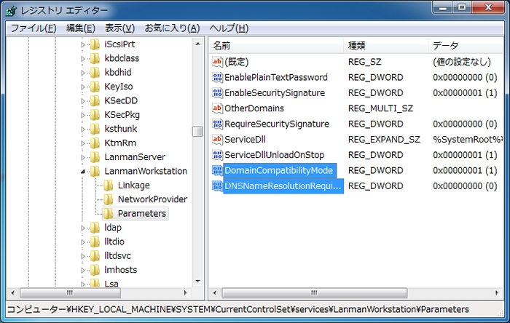

[3] | Open Property on your Windows PC and Click 'Change' button.
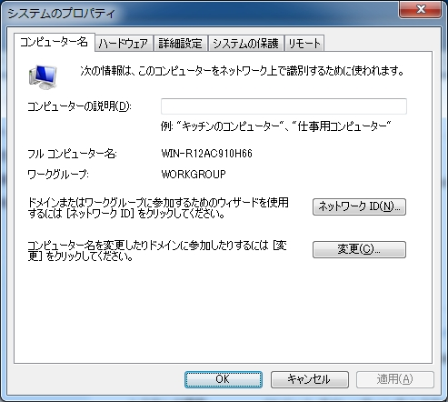

[4] | Check a box 'Domain' and Input domain name you set in smb.conf.

http://www.server-world.info/en/note?os=CentOS_6&p=samba&f=5

